PS3_Answer

1. Final state of running test_robot_movement(robot_type, room_type)

All tiles are cleaned finally.

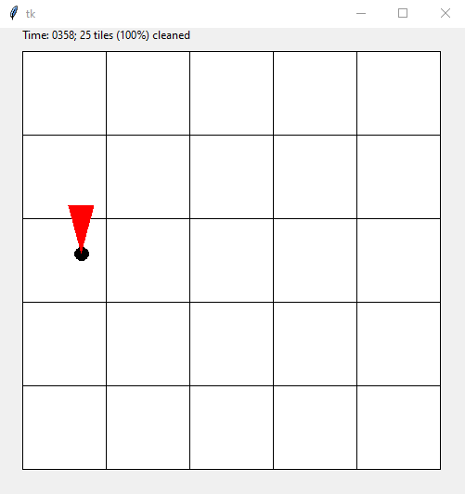

2.

(a). The relationship between required time to clean 80% of a 20*20 room and number of robots.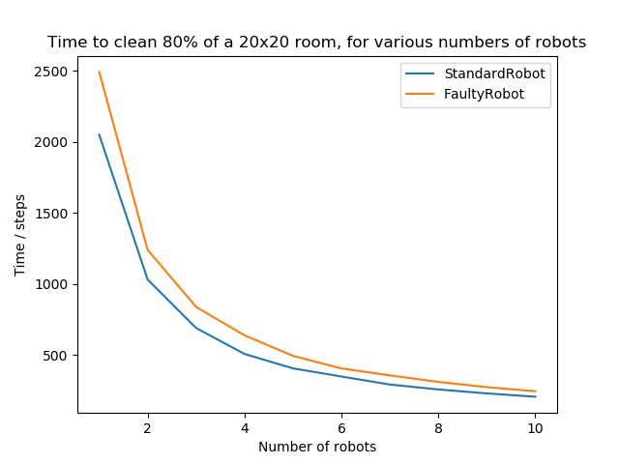

(b). The relationship between cost time to clean 80% of a 300-tile room and room shapes.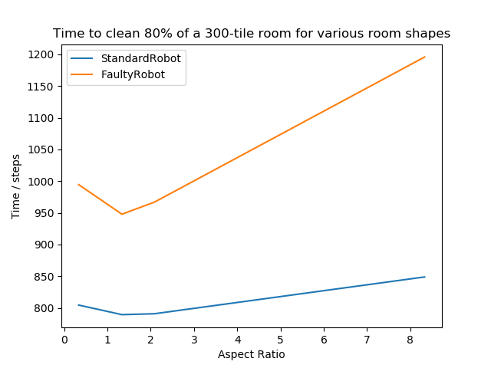

When the Aspect Ratio is close to 1 or the shape of empty room is close to a square, the cost time reaches minimum for both standard and faculty robots.